


The PaintCount Applet

PaintCount.java

// Displays the number of times paint has been called.
import java.applet.*;
import java.awt.*;

public class PaintCount extends Applet {
private int count = 0;

public void paint(Graphics g) {
count++;
g.drawString("Number of times paint called: " + count,
10, 20);
}

PaintCount.html

<APPLET CODE="PaintCount.class" WIDTH="200" HEIGHT="30">
</APPLET>

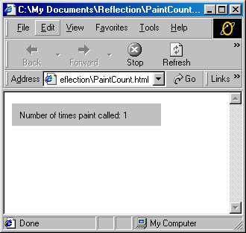

The Message Applet

Message.java

// Displays a message. The message and its coordinates are
// supplied as parameters.

import java.applet.*;
import java.awt.*;

public class Message extends Applet {
private String message;
private int x, y;

// Called once, when the applet is created
public void init() {
message = getParameter("message");
x = Integer.parseInt(getParameter("x"));
y = Integer.parseInt(getParameter("y"));
}

// Called each time the applet needs to be redisplayed
public void paint(Graphics g) {
g.drawString(message, x, y);
}
}

Message.html

<APPLET CODE="Message.class" WIDTH="250" HEIGHT="100">
<PARAM NAME="message" VALUE="Java rules!">
<PARAM NAME="x" VALUE="50">
<PARAM NAME="y" VALUE="25">
</APPLET>

